# Adare Website Test Document

https://seankellydundrum.github.io/index.html

## Navigation and clarity of presentation

Sample image 1 – Navigation Bar.

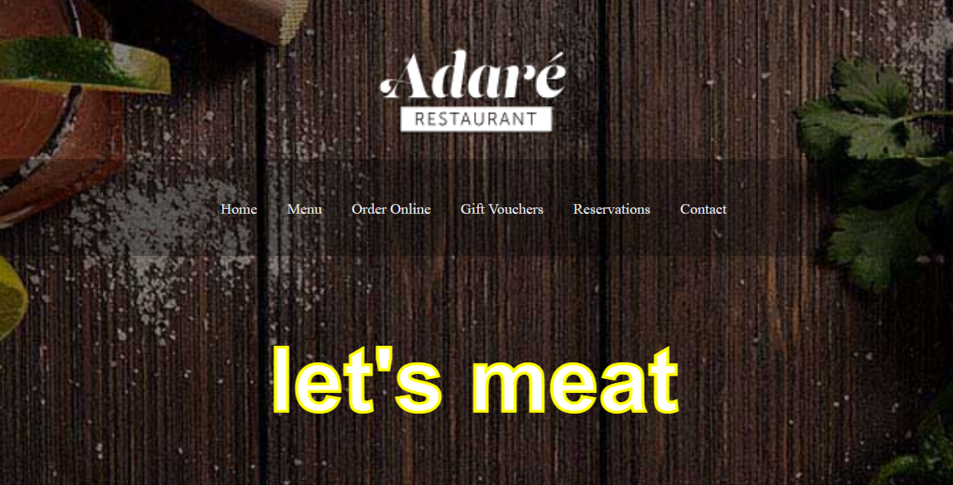

Sample video – Navigation Bar Hover function + All links working as expected



Tested website using Narrator Screen reader



# Cross browser

Chrome – Tested. Displays elements as expected

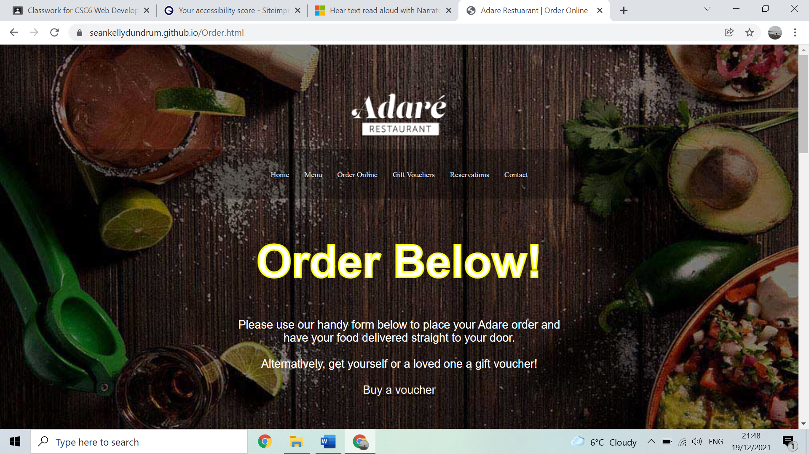

Homepage Main

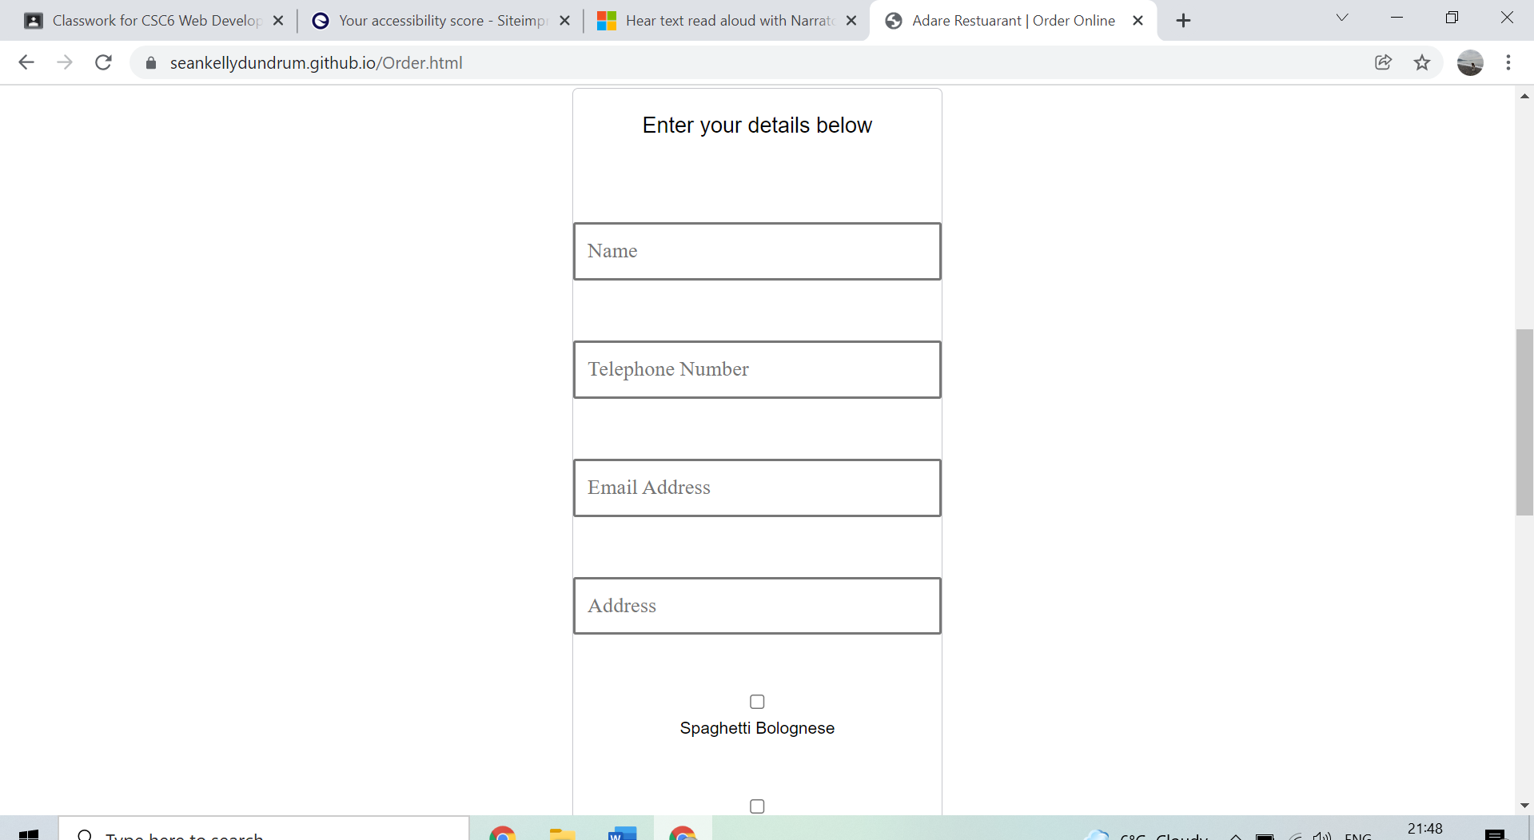

Order Form

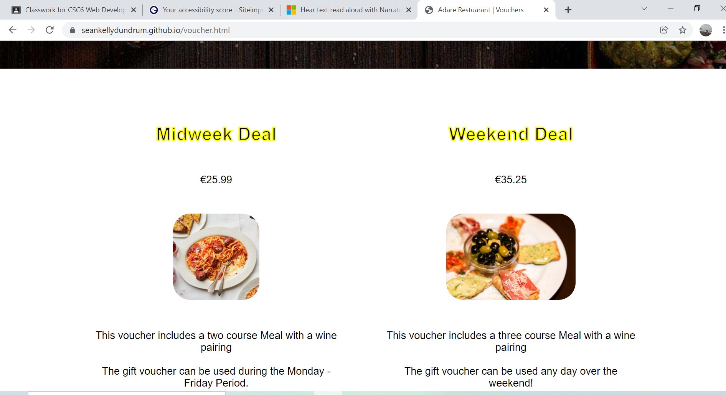

Voucher product cards

Edge – Tested. Displays elements as expected

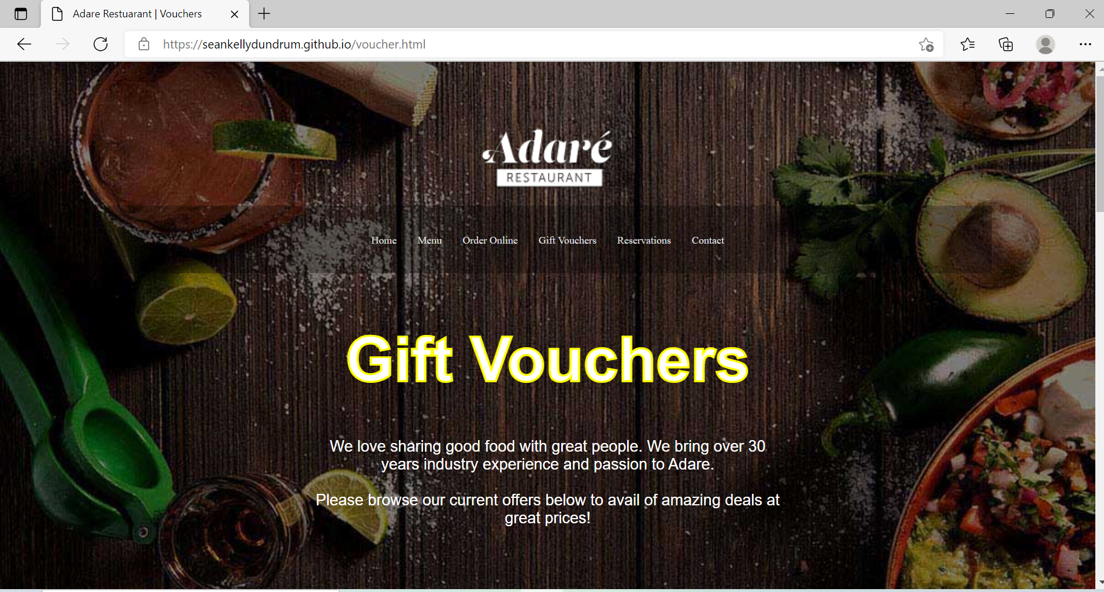

Homepage Main

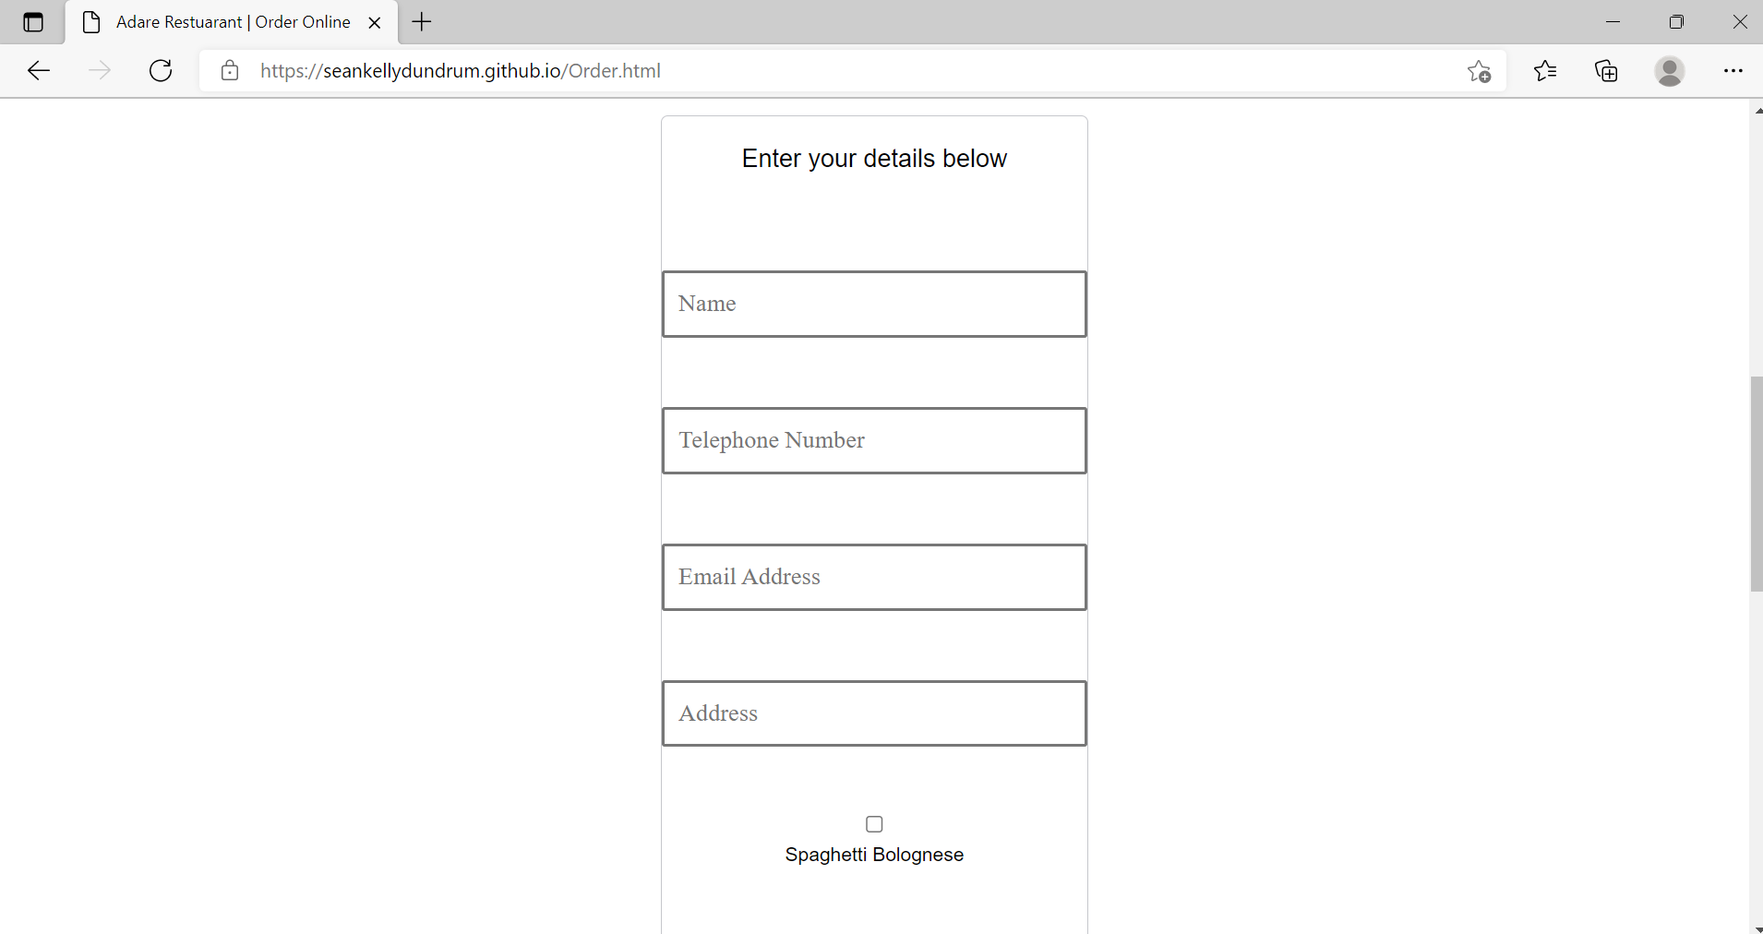

Order form

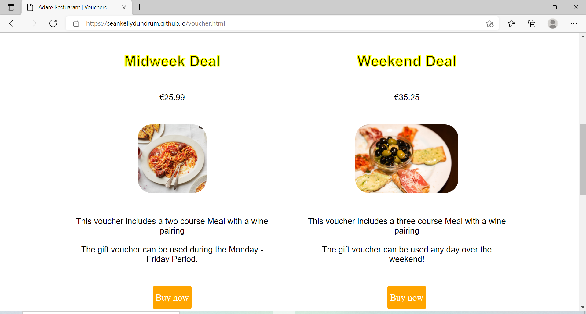

Voucher product cards